
Fakulteti i Shkencave Kompjuterike dhe Inxhinierisë

Emri i Projektit
AIRDATA

Studentet: Profesori:

Lejla Avdyli
Elze Ismajli

Erzen Talla

Dhjetor
2024

Përmbajtje

Introduction 3
Main Content
Database Design Overview
Entity Relationship Diagram ERD
Relational Schema
Specialization and Generalization
Derived and Multivalued Attributes
Justification for Design Choices 4
Conclusion 5
References 6

Introduction

The aim of this project is to design a database system tailored for an airport to manage critical operations efficiently. The system will store and organize data related to flights, passengers, employees, and other key airport functionalities. Using a systematic approach, we will start by defining the requirements, creating an Entity-Relationship Diagram (ERD), converting the conceptual model into a relational schema, and implementing the database using SQL.

This database system is designed to:
- Track flight schedules, passenger information, and ticket details.
- Organize airport staff roles and responsibilities.
- Ensure relationships between various components (e.g., passengers and flights) are well-defined.
- Handle data with scalability, accuracy, and flexibility.

Main Content

Database Design Overview

The database design includes the following main entities and their attributes:

1. Airports:

Stores airport details such as name, location (city/state), and capacity.

Each airport can have multiple flights originating or arriving at it.

2. Flights:

Tracks individual flights, including departure and arrival times, status, and associated airports (origin and destination).

A flight connects two airports.

3. Passengers:

Contains passenger personal information, such as names, email addresses, and phone numbers.

A passenger can purchase tickets for multiple flights.

4. Tickets:

Links passengers to their respective flights, with details like seat number and ticket price.

Represents a many-to-many relationship between passengers and flights.

5. Employees:

Stores details about all airport staff, including their positions and supervisors.

Employees are categorized into specialized groups, such as Pilots and Ground Staff.

6. Pilots:

A specialization of employees, pilots have unique attributes like license numbers.

7. Ground Staff:

Another employee specialization, with details about their specific departments.

Entity-Relationship Diagram (ERD)

The conceptual design of the database is represented in the following ERD. It illustrates the entities, their attributes, and relationships. 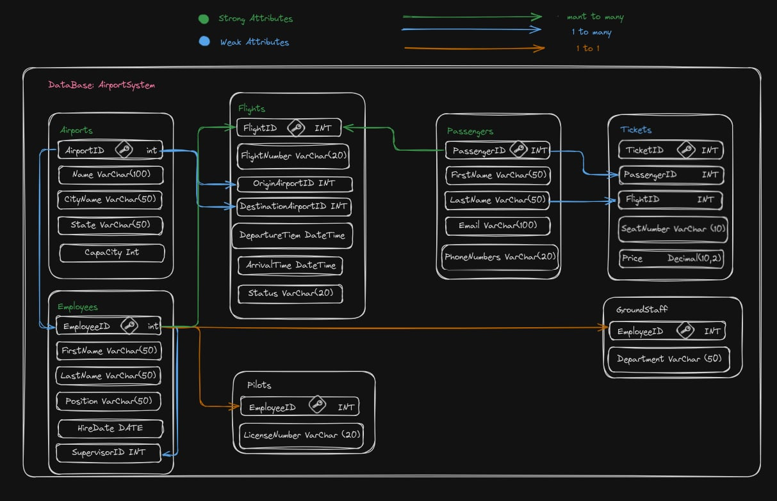

Explanation of Relationships:

One-to-Many (1:N):

An airport can have multiple flights originating or landing there.

A flight is linked to one origin airport and one destination airport.

An employee can have one supervisor, but a supervisor can manage many employees.

Many-to-Many (M:N):

Passengers can book multiple flights, and a single flight can accommodate multiple passengers. This is handled through the Tickets table.

One-to-One (1:1):

Specialized roles, such as pilots and ground staff, are associated with a single employee record.

Relational Schema

The relational schema derived from the ERD organizes the database into interconnected tables. These tables include Airports, Flights, Passengers, Tickets, Employees, Pilots, and GroundStaff. The attributes in each table adhere to normalization principles to avoid redundancy.

Entities and Attributes:

This database consists of strong and weak entities, ensuring data organization:

Strong Entities:

Airports: Represented by attributes such as AirportID (primary key), Name, CityName, State, and Capacity.

Flights: Includes FlightID (primary key), FlightNumber, OriginAirportID, DestinationAirportID, DepartureTime, ArrivalTime, and Status. These attributes track flight details comprehensively.

Passengers: Identified by PassengerID (primary key), with descriptive attributes FirstName, LastName, Email, and PhoneNumbers.

Weak Entities:

Tickets: Dependent on Passengers and Flights, with attributes TicketID (primary key), PassengerID, FlightID, SeatNumber, and Price.

Pilots: A specialization of Employees, defined by EmployeeID and LicenseNumber.

GroundStaff: Another specialization of Employees, characterized by EmployeeID and Department.

Specialization and Generalization

The Employees entity is designed with a top-down specialization approach, where specific roles like Pilots and GroundStaff are derived from the main Employee entity. This setup keeps the structure organized and makes it easier to retrieve data based on roles, while clearly defining each employee's responsibilities.

Derived and Multivalued Attributes

Although not directly included in this design, derived attributes such as TotalSeats for flights or OccupancyRate for airports could be added in the future to provide more detailed metrics. Multivalued attributes like PhoneNumbers for passengers could also be handled by creating separate tables, which would keep the database clean and scalable.

Justification for Design Choices

This design follows normalization principles to reduce redundancy and ensure data integrity. Strong entities like Airports and Flights manage key operations, while weak entities like Tickets add flexibility and extend functionality. The use of generalization for Employees simplifies the structure and makes managing employee roles straightforward. Additionally, binary relationships between entities ensure that connections remain clear and easy to maintain.

Conclusion

This project successfully designs a comprehensive database for managing an airport system. The system handles critical data related to flights, passengers, and staff while ensuring scalability and data integrity. The ERD and relational schema provide a clear representation of the database structure, making it easy to implement and maintain.

References

MySQL Documentation: https://dev.mysql.com/doc/

GitHub Repository: ( https://github.com/Elze11/Database-Project.git )

